




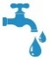
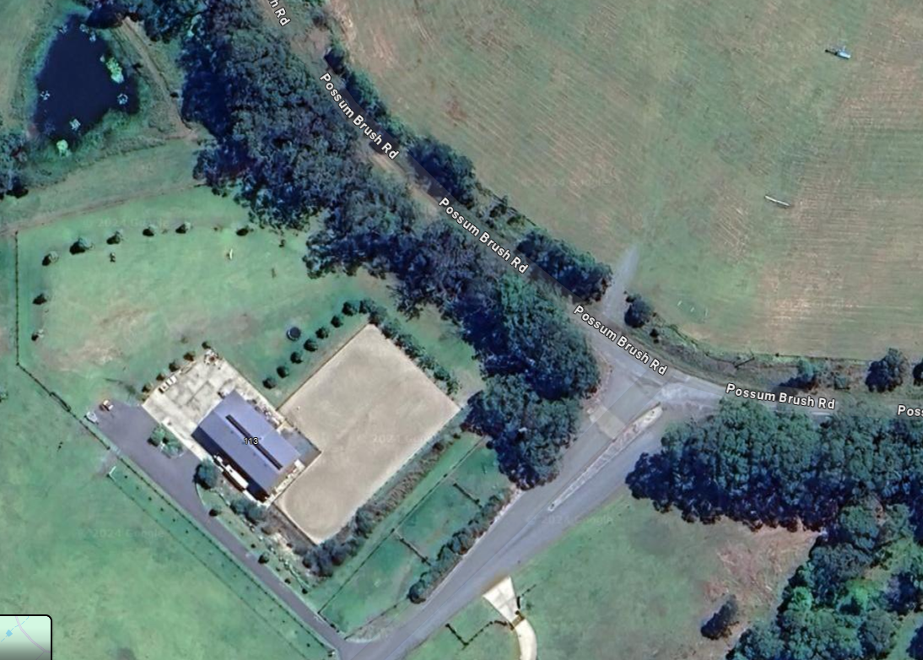
Overnight
Camping
Area

Toilet
Manure
Water
Accommodation
Stables
Grass Yards
Yards
Day
Parking
Area

Arena Access
Gate
Accommodation
S 1 | S 2
Y1 | Y2 | Y3
Grass 3
Grass 2
Grass 1

